8.110: By symmetry, 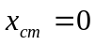. Using plane polar coordinates leads to an easier integration, and using the Theorem of Pappus 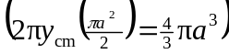 is easiest of all, but the method of Problem 8.109 involves Cartesian coordinates.

For the x-coordinate, 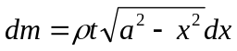, which is an even function of x, so 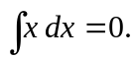 For the y-coordinate, 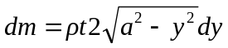, and the range of integration is from 0 to a, so

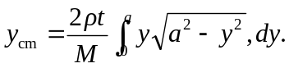

Making the substitutions 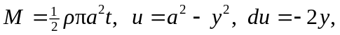 and


